Network Task Automator

Our Application is Network task Automator simply in this project our server has to do some tasks which we will talk about them briefly and return it to our client which is:

1. Performing automated network tasks and network configuration
2. Network Alarm
3. Network Statistics
4. Converting images, renaming files
5. Performing network equations
6. Word to pdf conversion
7. Audio/Video file transmission

First before talking about the tasks our server is a multithreaded server which has many ports every port is binded to a special socket for every task we have special port for it

Every socket is binded to its port number

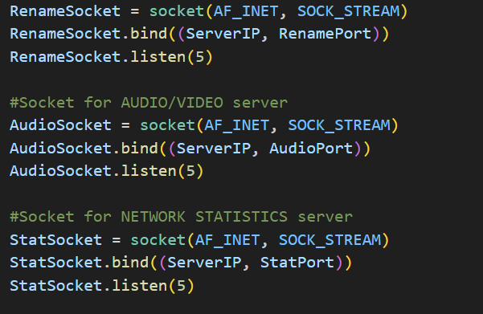

And then we create a thread for every task

1. Network Configuration :

We have implemented a function on the server which is

“ Configuration_client ” that acts like a DHCP server configuration that allow the server to to assign the clients from [C1-Cn] in our code to be assigned ip addresses from the server like the dynamic host configuration protocol this task can be implanted at port number = 5060

2. Network Alarm :

In this task we receive the port number from the client to check whether if it is closed or opened by using nmap port scanner at port number = 12000

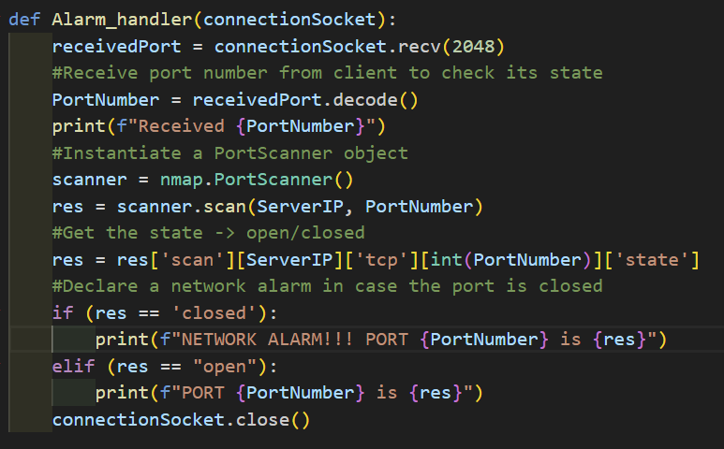

3. Network Statistics :

In this task the server returns to the clients the statistics of the ports in range whether if it is opened or close also using the nmapScanner and then we save the statistics in a file called stat_data at port number = 13000

4. Converting images, renaming files

Firstly there is two different functions for handling every task

In the image conversion handler the server receives from the user Image name , Image path and Image Format to be converted then we convert it by decoding the user inputs and finally remove the old image at port number=12001

Second Renaming files

In this function we receive from the user string containing the command to know to rename or not and the old file name and the new file name at port number=13002

5. Performing network equations:

In this task our client sends to the receiver the total information to perform Total delay which is the summation of propagation delay and conversion delay at port number 5050

1. Word to pdf conversion:

In this class we take from the user the file12345 name then we convert the word to pdf at portnumber=

7- Audio/Video file transmission:

